Model Representation

This Alloy document generates a model of the system in a precise moment. It represents a “photography” of the system and deals more with its global coherence than with the integrity of the transitions. In short, the most important properties of the model are:

* Users and external actors belong to the same system (Travlendar+)
* The users are distinguished in guest and registered users. Since only the registered ones can operate on the system, we are referring to them saying “users”.
* Every user can define some settings and the system mustn0t violate them when it suggests some paths.
* Every user owns a schedule containing every event they need to attend.
* The system suggests some paths for the users’ events, and those paths are grouped in the users’ daily paths.
* The system can suggest an alternative path for an event only if the main path has been refused or it is not “in time”.
* The external actors determine the presence of their transports as options in the system and (some of the actors) the possibility to buy tickets for those transports

Instance I

In this instance there are no users’ events, so the system doesn’t generate any suggested path. However, there exist users’ settings, schedules, daily paths and system’s external actors. The system is ready to add an event in the registered user’s schedule.

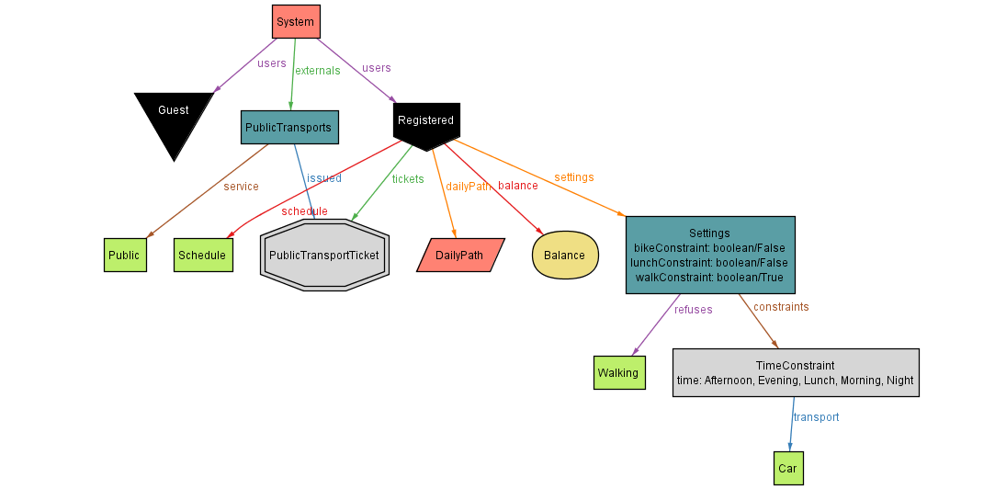

Instance II

In this instance, the registered user has one event in his schedule. The system suggests a main path for this event, but it is neither “in time” or “accepted by the user”. So, the system suggests an alternative path for the same event, which allows the user to be in time.

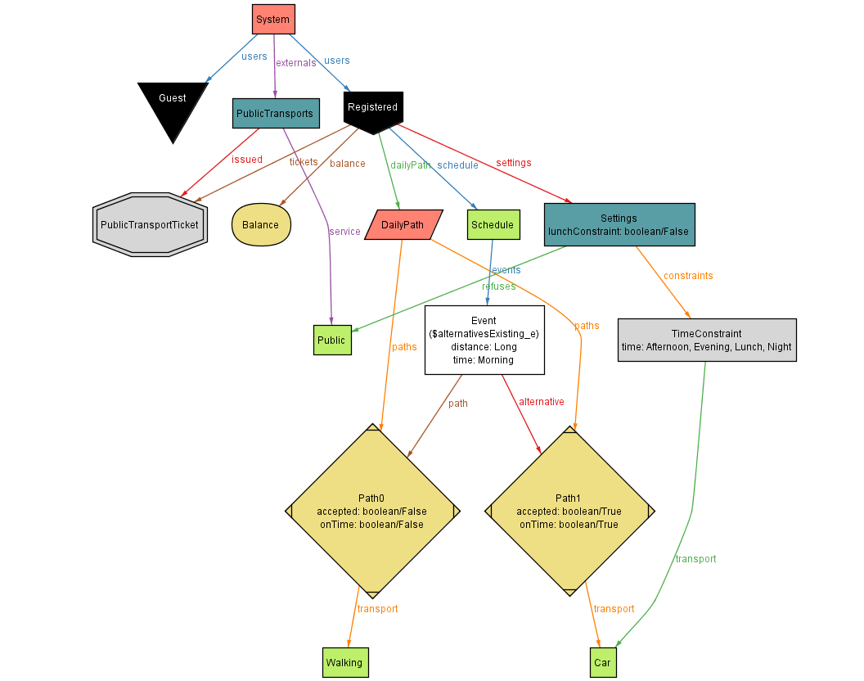Instance III

In this instance, both Public Transports and Train Service exist as external actors in the system. The registered user owns in his account a single train ticket and a public transports ticket. The link between the tickets and the actors which allowed their purchase is highlighted by the relation “issued”.

